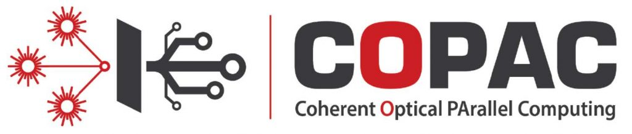

March 23rd, 24th and 25th 2021

Parallel Computing Quantum Devices
As the demand for more powerful computing resource increase, new computing approaches are actively developed.
The FET-Open European project COPAC, Coherent Optical Parallel Computing, Pr Françoise Remacle coordinator, is one of such endeavors : COPAC aims at implementing massively parallel quantum logics on solid state quantum dot devices operating at room temperature using sequences of fs laser pulses.
COPAC organizes an online symposium on March 23rd, 24th and 25th 2021, that covers the different facets non linear optics, materiel science, quantum devices and quantum computing of the project.

March 23rd
Paris Time
- 2:30pm – Introduction by the Chair Pr. Elisabetta Collini – University of Padova, Italy
- 2:35pm – « Physical Approaches Towards Understanding Metabolic Networks. » – Pr. James R. Heath – Institute for Systems Biology, Seattle, USA
- 3:20pm – « Controlling the properties of complex materials with light » – Pr. Daniele Fausti – University of Trieste, Italy
- 4:00pm – Poster Session
- 4:30pm – « Quantum Dynamics for Real-Time Processing of Excitonic Energy: Tuning Vibronic Coupling to Steer Energy Transfer within a Photosynthetic Complex » – Pr. Greg Engel – The University of Chicago, USA
- 5:10pm – Discussions and conclusion with Pr. Elisabetta Collini, Pr. James R. Heath, Pr. Daniele Fausti and Pr. Greg Engel

March 24th
Paris Time
- 2:30pm – Introduction by the Chair Pr. Yossi Paltiel – The Hebrew University of Jerusalem, Israël
- 2:35pm – « Halide Perovskite Nanocrystals: Synthesis, the Role of the Surface, Heterostructures » – Pr. Liberato Manna – Institute of Technology, Genova, Italy
- 3:20pm – « Quantum Rotors : Magnetometers, accelerometers and rotation sensors » – Pr. Yehuda Band – Ben-Gurion University, Israel
- 4:00pm – Poster Session
- 4:30pm – « COPAC Coherent Optical Parallel Computing » – Pr. Elisabetta Collini – University of Padova, Italy
- 5:10pm – Discussions and conclusion with Pr. Yossi Paltiel, Pr. Liberato Manna, Pr. Elisabetta Collini, Pr. Yehuda Band

March 25th
Paris Time
- 9:00am – Introduction by the Chair Pr. Raphael D. Levine – The Hebrew University of Jerusalem, Israël
- 9:05am – « Ultrafast and ultracold quantum simulator with attosecond precision » – Pr. Kenji Ohmori – Institute for Molecular Sciences, Okazaki, Japan
- 9:45am – « Quantum simulations and the difficulty of solving many-body problems » – Pr. Ignacio Cirac – Max Planck Institute for Quantum Optics, Garching, Germany
- 10:25am – Computational Challanges and stochastic algorithms in large scale Machine Learning – Pr. Pr. Naftali Tishby – The Hebrew University of Jerusalem, Israel
- 11:05am – « Next-generation optimization accelerators : solving NP-Hard problems using integrated coherent ising machines or memristive crossbar arrays » – Dr. Thomas Van Vaerenbergh – Hewlett Packard Enterprise – Belgique
- 11:45am – Discussions and conclusion with Pr. Raphael D. Levine, Pr. Kenji Ohmori, Pr. Ignacio Cirac, Pr. Naftali Tishby and Dr. Thomas Van Vaerenbergh

COPAC IS AN EUROPEAN PROJECT FINANCED BY :
H2020-FETOPEN-1-2016-2017-766563

PROJECT PARTNERS:
